Computer Networks 1
Lab 10
Static Routing, RIP

Names:
Student No:

Objectives
- Understanding Static routing, RIP configuration.
- Practising Static routing, RIP on Cisco Packet Tracer.

Content and Practice
Note: This Lab is intended to cover 4 periods. The first 2 periods are for Static Routing, the rest are for RIP.
I. Static routing:

1. Information About Static Routing
Routers forward packets using either route information from route table entries that you manually configure or the route information that is calculated using dynamic routing algorithms.
Static routes, which define explicit paths between two routers, cannot be automatically updated; you must manually reconfigure static routes when network changes occur. Static routes use less bandwidth than dynamic routes. No CPU cycles are used to calculate and analyze routing updates.
You can supplement dynamic routes with static routes where appropriate. You can redistribute static routes into dynamic routing algorithms but you cannot redistribute routing information calculated by dynamic routing algorithms into the static routing table.
You should use static routes in environments where network traffic is predictable and where the network design is simple. You should not use static routes in large, constantly changing networks because static routes cannot react to network changes. Most networks use dynamic routes to communicate between routers but might have one or two static routes configured for special cases. Static routes are also useful for specifying a gateway of last resort (a default router to which all unroutable packets are sent).

2. Configuring Static Routing
You can configure a static route on the router.
Static routing is manually configured by command: ip route

SUMMARY STEPS
1. configure terminal
2. ip route {ip-prefix | ip-addr/ip-mask} {[next-hop | nh-prefix] | [interface next-hop | nh-prefix]} [name nexthop-name] [tag tag-value] [pref]
3. (Optional) show ip route
4. (Optional) copy running-config startup-config

TIP: You can use ip route command in a simple way:
ip route <destination network> <subnet mask of destination network> <output gateway of current configured router | next hop’s ip address>

Practice 1:
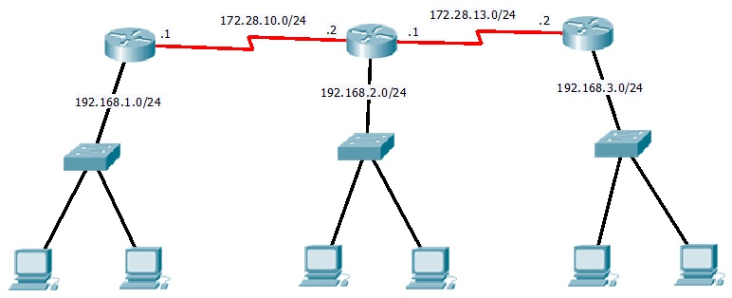

Requirement:
Configure static routing for 3 routers so that every computer in the topology can ping one another.

II. RIP
RIP is a relatively old but still commonly used interior gateway protocol created for use in small, homogeneous networks. It is a classical distance-vector routing protocol.
RIP uses User Datagram Protocol (UDP) data packets to exchange routing information in small internetworks.
RIP uses the following two message types:
•Request - request route updates from other RIP-enabled routers.
•Response - sent every 30 seconds by default. The router also sends response messages after it receives a Request message. The response message contains the entire RIP route table.
RIP uses a hop count for the routing metric. The hop count is the number of routers that a packet can traverse before reaching its destination. A directly connected network has a metric of 1; an unreachable network has a metric of 16. This small range of metrics makes RIP an unsuitable routing protocol for large networks.
There are 2 versions of RIP. RIP version 1 and RIP version 2.
RIP version 1 uses broadcast and is a classful routing protocol without authentication.
RIP version 2 is the most recent version of RIP used in IPv4. It includes a number of enhancements over the original RIP version 1, including support for subnet masks and classless addressing, explicit next-hop specification, route tagging, authentication and multicast. For compatibility, it uses the same basic message format as RIP version 1, putting the extra information required for its new features into some of the unused fields of the RIP version 1 message format.
RIP Configuration Task List:

Enabling RIP

 | Command | Purpose
Step 1 | Router(config)#router rip | Enables a RIP routing process, which places you in router configuration mode.
Step 2 | Router(config-router)#network ip-address | Associates a network with a RIP routing process.

Specifying a RIP Version
Configure the software to send and receive packets from only one version:
Command | Purpose
Router(config-router)#version{1|2} | Configures the software to receive and send only RIP Version 1 or only RIP Version 2 packets.

Disabling Automatic Route Summarization

Command | Purpose
Router(config-router)#no auto-summary | Disables automatic summarization.

TIP: if you do not specify the RIP version by the command Router(config-router)#version{1|2}, cisco IOS automatically forces RIP to be version 1 by default. Therefore, you can configure RIP version 1 simply by:
Router(config)#router rip
Router(config-router)#network ip-address

For RIP version 2,
Router(config)#router rip
Router(config-router)#version 2
Router(config-router)#no auto-summary (if you want to disable automatic summarization)
Router(config-router)#network ip-address

Verifying IP Route Summarization
Router#show ip protocols
Routing Protocol is "rip"
Sending updates every 30 seconds, next due in 8 seconds
Invalid after 180 seconds, hold down 180, flushed after 240
Outgoing update filter list for all interfaces is
Incoming update filter list for all interfaces is
Redistributing: rip
Default version control: send version 2, receive version 2
Interface Send Recv Triggered RIP Key-chain
Ethernet2 2 2
Ethernet3 2 2
Ethernet4 2 2
Ethernet5 2 2
Automatic network summarization is not in effect
Address Summarization:
10.a.0.0/16 for Ethernetx/y
Router#show ip rip database
10.0.0.0/8 auto-summary
10.x.y.0/24 directly connected, Ethernet2
10.a.0.0/8 auto-summary
10.b.0.0/16 int-summary
Router#show ip route

Practice 2: Complete the Lab practice in Practice 1 using RIP version 1 for each router.
Practice 3: Complete the Lab practice in Practice 1 using RIP version 2 for each router, disable automatic summarization on all routers. After all configuration is done, use the command Router#show ip route to check the routing table, compare this with the routing table in Practice 2.

III. Submission
Complete the practice 1, 2, 3 on Cisco Packet Tracer. Compress all files into Lab10_<student_code>.zip and submit this file to your instructor.

References:
http://www.cisco.com/en/US/docs/ios/12_2/ip/configuration/guide/1cfrip.html
http://www.cisco.com/c/en/us/td/docs/switches/datacenter/sw/5_x/nx-os/unicast/configuration/guide/l3_cli_nxos/l3_rip.html
http://www.tcpipguide.com/free/t_RIPVersion2RIP2MessageFormatandFeatures-2.htm

